 2014 Calendar Contest Rules
We’re looking for the next Calendar Boy/Girl for our 2014 VCOI Calendar Contest
*****VCOI Calendar Contest Rules*****
All photos entered must be submitted with a $10 entry fee per photo.
Checks should be made out to VCOI.
The photo receiving the most votes will win a cash prize based on the number of entries!
PLEASE insure that your photo meet these minimum requirements!!!

- Photo must be taken by a VCOI member – NO PROFESSIONAL OR COPYRIGHTED PHOTOS
- VIZSLAS ONLY – no other breeds please
- You may include humans in the photo – NO FACES!
- No photos can be shopped changed or have anything added to them.
- All entries must be made in 8x10 print copy
- Photo submissions must be labeled on the back to include:
  - Photographer info – your name, phone number and email address
  - Dog info – name(s), owner(s), and a caption describing your photo that we may choose to include in the calendar
Photos submitted with a SASE will be returned. All others remain the property of VCOI.
Winning photographs will be notified and MUST be submitted in
digital format to be included in the calendar.

Submit your 8x10 photos by mail to: Shelley Gabriel
106 Coghill St
Joliet, IL 60435

Mailed entries must be received by May 20^{th.}
You may also submit your 8x10 print(s) in person at the Busch Farm Saturday May 25^{th,}
and a digital copy may be submitted at that time as well for convenience in case you win a spot in the calendar
If you have any questions? shebbykay@hotmail.com
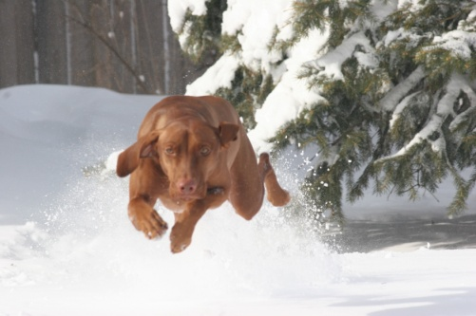

2013 Calendar Cover
Cheyenne

